Brandon Tenorio

Gary Thai

CMSC204

Fall 2021

Project 5

The focus of this project was on trees and how to implement them to decode morse code. I was tasked with creating a tree data structure centered around decoding a String of periods and dashes representing morse code. While building my MorseCodeTree class, I used the book, the powerpoints, and some resources of my own to use recursion in order to implement all of the methods of the class correctly. While I first found it tricky to implement the buildTree method, with enough time I was able to fully understand how to determine where each node should go in the tree. Overall, this was a great project to hone down my tree traversing and implementation skills.

Test cases

Test 1:

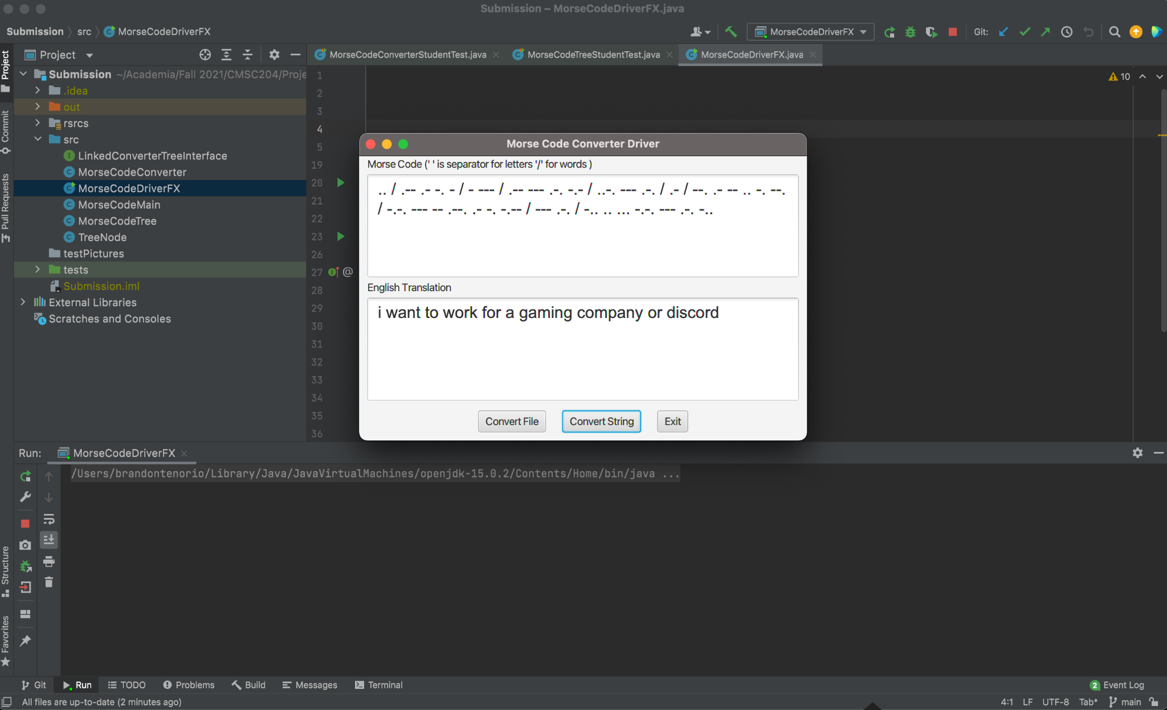

Test 2:

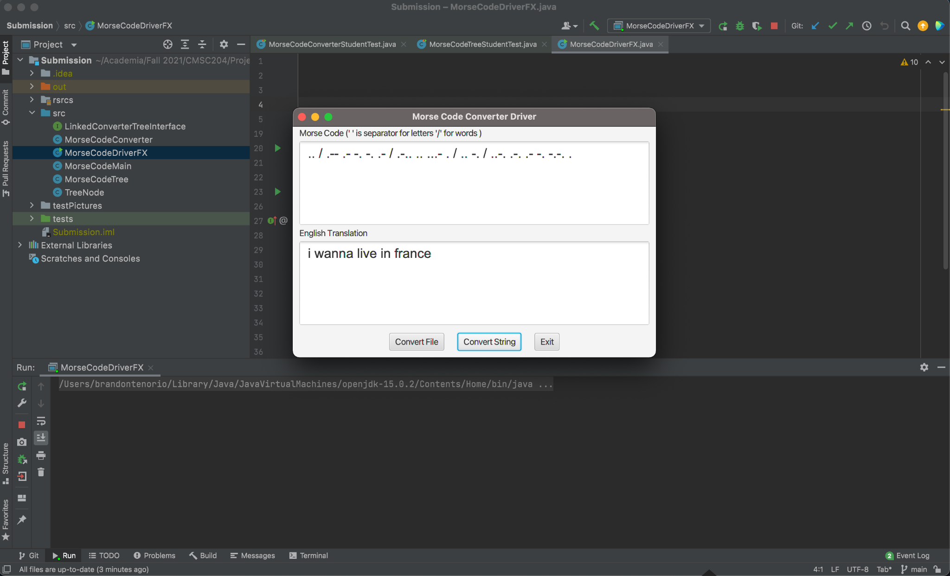

Test 3:

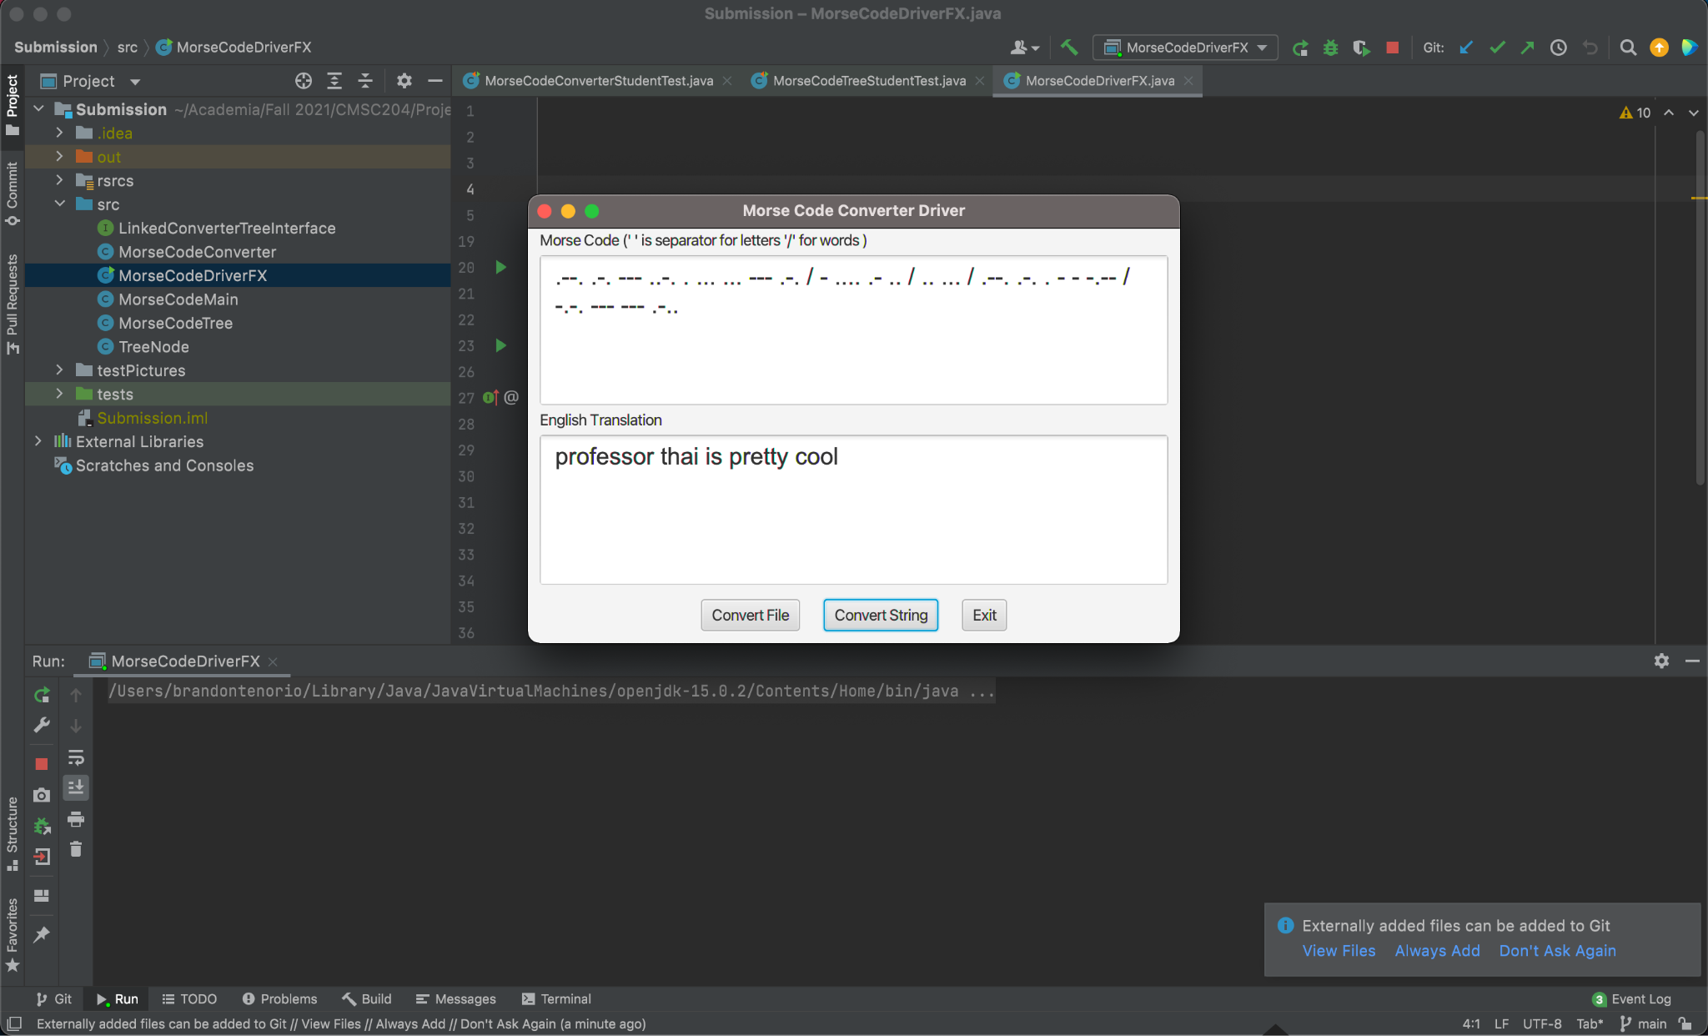

Test 4:

